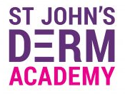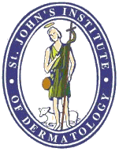
St John’s DermAcademy Dermoscopy Course
29th March 2019, Royal College of Physicians, London
Programme

09:00 | Registration
Session 1: Non-melanoma skin cancer
Chair: Dr Katie Lacy, Dr Clare Kiely
09:25 – 09:30 | Welcome & Introduction | Dr Katie Lacy
09:30 – 10:10 | Basal Cell Carcinoma | Dr Rakesh Patalay
10:10 – 10:25 | Quiz
10:25 – 11:05 | Squamous Cell Carcinoma, Bowens Disease, Actinic Keratosis, and others | Dr Amilios Lallas
11:05 – 11:20 | Quiz
11:20 – 11:40 | Tea Break
Session 2: Clinicopathological Correlation
Chair: Dr Amilios Lallas, Dr Rakesh Patalay
11:40 – 12:10 | Pathological Correlates with Dermoscopy | Dr Catherine Stefanato
12:10 – 12:50 | Clinicopathological Correlation Cases | Dr Katie Lacy  Dr Catherine Stefanato
12:50 – 13:50 | Lunch
Session 3: Pigmented Lesions and Melanoma
Chair: Dr Eleanor Higgins, Dr Catherine Stefanato
13:50 – 14:35 | Melanoma | Dr Ashfaq Marghoob
14:35 – 14:50 | Quiz
14:50 – 15:30 | Mucosal Pigmented Lesions | Dr Amilios Lallas
15:30 – 15:40 | Quiz
15:40 – 16:00 | Tea Break
16:00 – 16:40 | Acral Lesions | Dr Ashfaq Marghoob
16:40 – 16:50 | Quiz
16:50 – 17:00 | Closing Remarks
 | Close of meeting

